** *ASSIGNMENT #02***

***TITLE: EXPLANATION OF CPU, ALU, MU, CU, REGISTER AND CACHE MEMORY***

***COURSE: INTRODUCTION TO COMPUTING***

***STUDENT ID: CSC-17F-047***

***CLASS: BSCS***

***SECTION: 1B***

***SUBMITTED BY: SUBMITTED TO:***

***WAJIHA M.ISMAIL SIR.AMEEN KHUWAJA***

**CPU:**

CPU is the abbreviation of Central Processing Unit. It is a brain of computer. It is one of the leading part of computer, which brings the instructions to computer program. CPU do multiple tasks like arthimethical, logical and input/output operations. Structure of CPU is changed by day’s promotion but it do the same operations. First CPU was introduced in 1940s which works with first computer EDVAC(Electronic Discrete Variable Automatic Computer). It have microprocessor, memory and motherboard. Logical core is called a thread and multi core processor are called physical core. Multi core system have more than one core,the common CPUs are dual core and quad core. Multi core are those core which is a single computing components which independent on 2 or more processing units.

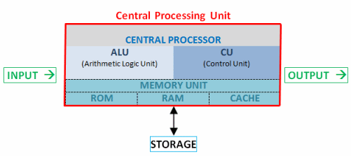 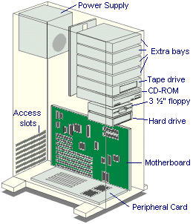

* **MICRO-PROCESSOR:**

It is IC (Integrated Circuit) that have milllions of transistors connected through the small aluminium wires. It have processing abilities to control the PC through networking with an additional electronic modules on motherboard.

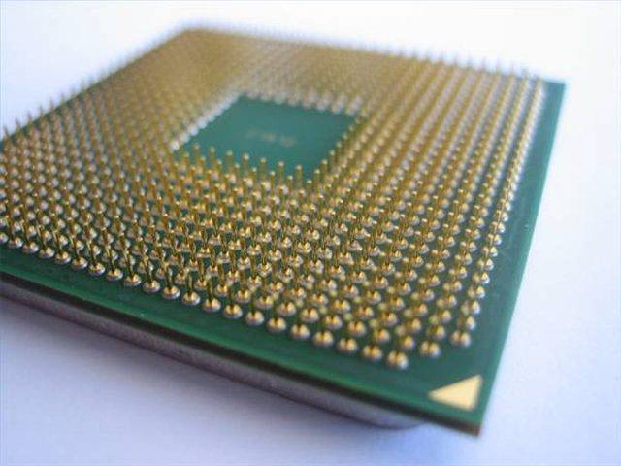

* **MOTHERBOARD:**

It is a central PCB(Printed Circuit Board) in several modern computers and it hold several of key components of system, which delivers connecter to other peripherals. It is sometimes known as planar board, main board, system board, or on Apple computers it is known as logic board.

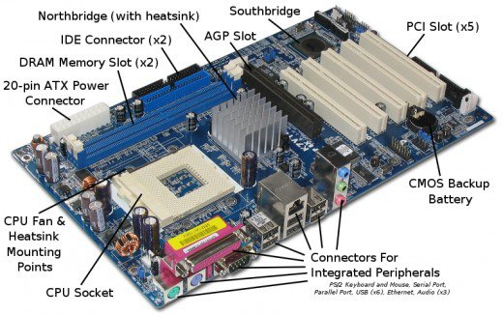

**ALU:**

ALU is the abbreviation of Arithmetic and Logic Unit. ALU is the place where data is processing. It is a digital electronic circuit performs arithmetic and logic operations like addition, subtraction , shifting operation and logic operators Boolean comparison like AND, OR, XOR and NOT operations. It is made for integer calculations. ALU often handle the multiplication, the result is also an integer. ALU cannot performs the division because of their fraction results, it is performs by FPU (Floating Point Unit) which performs non-integer calculations. ALU is the essential structure block of several kinds of computing circuits with CPU (central processing unit), FPU (floating point unit), and GPU (graphics processing unit). A single CPU, FPU or GPU have many ALU. By John Von Neumann ALU idea in 1945 in a boom of foundation for a fresh computer known as EDVAC.

ALU is the combinational logic circuit. Its output will transform asynchronously in reaction to input modifications. The outer circuit linked to the ALU is answerable for confirming the constancy of ALU input signals in the operations. It have two operations: fixed point and floating point. It also have a complex operation in which its multiply two numbers and then add it.

ALU must practice number by the similar setup as the respite of digital circuit. On behalf of modern processor, this is constantly on the two balance binary numbers demonstration. Primary computer used a extensive variety of number systems, containing one’s complement, sign-magnitude format, and even true decimal system, with ten tubes per digit.

ALUs for every one of these numeric system had dissimilar projects, and that inclined the current partiality for two’s complement, as this is the demonstration that creates it easier for the ALU’s to evaluate additions and subtractions.

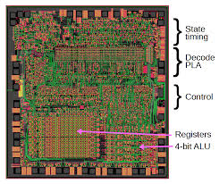

**SYMBOL OF ALU:**

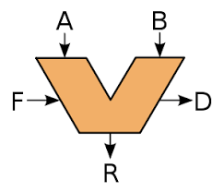

A and B is denoted to the input to ALU.

R is denoted to the output or result.

F is denoted to the code or the instructions which is from the control unit.

D is denoted to output status which indicates the cases.

**CU:**

CU is the abbreviation of control unit. It is the circuit in the CPU, which controls the operations in the CPU and directing traffic in a sense. Control unit perform their functions which depends on CPU types. The varying units of design among all the dissimilar CPUs will regulate the function of CU. It can hold altogether the processor control signals and nonstop all flows of input and output, fetches code for instructions from micro-programs and also nonstop other units and models which providing by control and timing signals. It directs the signals to other portion of computer. It synchronizes the complete system by significant devices what to do and when to do.

Control unit was generally well-defined as one separate portion of 1946 link ideal of Von Neumann architecture. The function of control unit is to create appropriate timing and control signals to all processes in the computer. Control unit is the brain in the brain. It handles the movement of data among processor, memory and peripheral. The model of device needs control unit are CPU and GPU.

Control unit leads the whole computer system to carry out stored program instructions. Control unit need to connect with both the ALU and main memory. Control unit coaches the ALU that which performs logical and arithmetic operations. Control unit manage the actions of the other two units as well as all the peripherals and auxilary storage devices connected to the computer.

It contains two types. One is hardwired control unit, which are implemented over use of sequential logic units or circuits like gate, filflops, decoders in hardware. It is normally faster than micro-programmed designs. Architecture is in reduced instruction set computer (RISC) as they used simpler instruction set. It contain of instruction register, no of control logic gates, two decoders, and 4-bit sequence counter. Second is micro-programmed control unit, which were prearranged as a sequence of micro-instructions and kept in different control memory. Output of controller are prearranged in micro instructions and the can be easily substituted. It is implemented using programming approach. Orders of micro operations are carried out by performing a program contain micro-instructions. Micro program containing of micro instructions is kept in a control memory in a control unit. Execution of micro instruction is answerable for generation of a set of control signal. It consist of next address generator, control address register, control memory, and control data register.

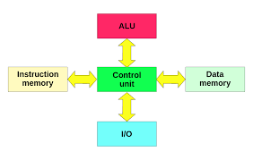

**MU:**

MU is the abbreviation of Memory Unit. Memory states to the physical devices used to collection of program or data on a short-term and always basis for use in a computer or other digital electronic device.

**TYPES OF MEMORIES**:

There are two types of memories.

* **PRIMARY MEMORY:**

It contains two types. One is RAM and second is ROM. RAM contains two types SRAM and DRAM. ROM contains three types PROM, EPROM and EEPROM.

* **SECONDARY MEMORY**:

It contains two types. One is sequential (e.g. Magnetic Tape) and second is random-magnetic optical.

**MAIN MEMORY:**

Main memory is also known as primary memory. Memory is one of the very important parts of computer without it you cannot run the computer as all the programs to start our computer are installed in it, also it is volatile in nature i.e. it will store information till it is on and then after switching off it forgets everything it is only a temporary not permanent. There are two types of main memory.

1. Random Access Memory(RAM)
2. Read Only Memory(ROM)

**RANDOM ACCESS MEMORY:**

It stores data temporary. It is volatile in nature. It stores initial, intermediate and final data of process. There are two types of RAM:

1. Static Memory
2. Dynamic Memory

**STATIC MEMORY:**

It refreshes itself on the command until it is commanded to refresh itself. It do not cause any type of delay in the process by refreshing itself. It is costlier. It is used in launching of rockets, where there is no place for even a fraction of delay in process.

**DYNAMIC MEMORY:**

It refreshes itself in every few milliseconds, to arrange all the data and to make the full use of the processsor and process the as fast as possible and also to utilize all the memory of the computer. It is comparatively cheaper in price. It is used in common PCs.

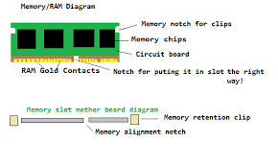

**READ ONLY MEMORY:**

It stores data permanently. It is non-volatile in nature. It stores the code to run the computer, BIOS (Basic Input Output System). There are three types of ROM:

1. Programmable ROM
2. Erasable PROM
3. Electronically EPROM

**PROGRAMMABLE ROM:**

It is use and throw ROM chip. If the program written in the chip is in use, it’s will work but soon as there need a change in the program, a new program will have to be written on other chip which creats a lot of pollution as it cannot be recycled . to solve this problem EPROM was invented.

**ERASABLE PROM:**

To avoid all the scrap produced by PROM, EPROM was invented. The program written in it can be erased by the action of ultra violet rays on the chip. The problem with it was that , by the action of UV rays on it, the chip was damaged, and could not be used after 2-3 times of erases and also if you want erase a little part of the program, it will remove all the data and you will have to start from the starting point.

**ELECTRICALLY EPROM:**

To resolve the problem of EPROM, EEPROM was invented, which can be erase the data electronically, then rewriting the program in it. If there has to be a little change in chip, the whole data is not to be erased, only the effective part can erased and rewritten on it.

**SECONDARY MEMORY:**

Primary memory has a limited storage capacity and not permanent. Secondary storage devices are used to store large amount of data permanently. It is not non-volatile in nature, it stores all the data permanently in it after the computer is turned off. There are various type of secondary memory.

**RANDOM MEMORY**:

It consist of two types:

1. Magnetic Form
2. Optical Form

**MAGNETIC FORM:**

It is storage of data on medium. Magnetic storage uses different patterns of magnetization in a magnetizable material to store data and is a form of non-volatile memory. The information is accessed using one or more read and writes heads. E.g. hard disk, floppy disk, recording etc.

**OPTICAL FORM:**

The compact disk are optical way to storing the information. The CDs are relatively very cheap and handle up to huge sum of input e.g. 70MB to 100GB. There are three types of CDs

1. CD-ROM(compact disk read only memory)
2. CD-R(recordable)
3. CD-RW(rewritable)

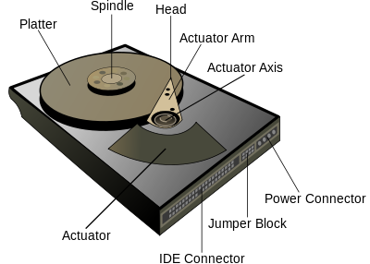

**REGISTER:**

**Register** are used to rapidly accept, store, and transfer data and instructions that are used instantly by the [CPU](http://ecomputernotes.com/fundamental/introduction-to-computer/what-is-cpu), there are various kinds of [Registers](http://ecomputernotes.com/fundamental/input-output-and-memory/what-is-registers-function-performed-by-registers-types-of-registers) those are used for various determination. Among of the some Mostly used Registers named as AC or **Accumulator**, Data Register or DR, the AR or **Address Register, programcounter**([PC](http://ecomputernotes.com/fundamental/introduction-to-computer/personal-computer)),**MemoryDataRegister**(MDR),**Index**[register](http://ecomputernotes.com/fundamental/input-output-and-memory/what-is-registers-function-performed-by-registers-types-of-registers)*,*Memory Buffer Register*.*

These Registers are used for performing the various Operations. While we are working on the System then these Registers are used by the **CPU the Operations.** **for Performing** When We Gives Some Input to the System then the **Input will be Stored into the Registers** and When the System will give us the Results after Processing then the Result will also be from the Registers. So that they are used by the **CPU for Processing the Data**which is given by the User. Registers Perform :-

1)**FETCH**: The Fetch Operation is used for taking the instructions those are given by the user and the Instructions those are stored into the Main Memory will be fetch by using Registers.

2)**DECODE**: The Decode Operation is used for interpreting the Instructions means the Instructions are decoded means the CPU will find out which Operation is to be performed on the Instructions.

3)**EXECUTE**: The Execute Operation is performed by the CPU. And Results those are produced by the CPU are then Stored into the Memory and after that they are displayed on the user Screen.

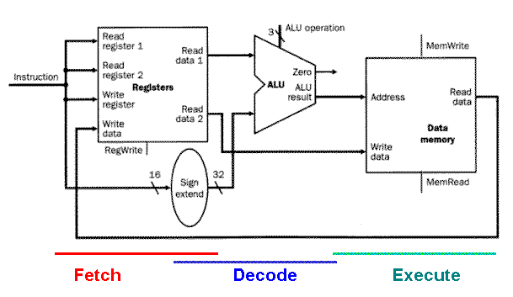

## **Types of Registers are as Followings**

### MAR STAND FOR MEMORY ADDRESS REGISTER

This register holds the [memory](http://ecomputernotes.com/fundamental/input-output-and-memory/what-are-the-different-types-of-ram-explain-in-detail) addresses of data and instructions. This register is used to access data and instructions from memory during the execution phase of an instruction**. Suppose CPU wants to store some data in the memory or to read the data from the memory. It places the address of the-required memory location in the MAR.**

### **Program Counter**

The **program counter (PC),** commonly called the **instruction pointer**(IP) in Intel x86 microprocessors, and sometimes called the **instruction address register**, or just part of the instruction sequencer in some [computers](http://ecomputernotes.com/fundamental/introduction-to-computer/what-is-computer), is a processor register

It is a 16 bit special function register in the 8085 microprocessor. It keeps track of the the **next memory address** of the instruction that is to be executed once the execution of the current instruction is completed. **In other words, it holds the address of the memory location of the next instruction when the current instruction is executed by the microprocessor.**

### ****ACCUMULATOR REGISTER****

This Register is used for storing the Results those are produced by the System. When the CPU will generate Some Results after the Processing then all the Results will be Stored into the**AC Register.**

### ****MEMORY DATA REGISTER (MDR)****

MDR is the register of a [computer](http://ecomputernotes.com/fundamental/introduction-to-computer/what-is-computer)'s control unit that contains the **data to be stored in the computer storage**(e.g. [RAM](http://ecomputernotes.com/fundamental/input-output-and-memory/what-are-the-different-types-of-ram-explain-in-detail)), or the **data after a fetch from the computer storage.** It acts **like a buffer** and holds anything that is copied from the memory ready for the processor to use it.**MDR hold the**[information](http://ecomputernotes.com/fundamental/information-technology/what-do-you-mean-by-data-and-information)**before it goes to the decoder.**

MDR which contains the data to be written into or readout of the addressed location. For example, to retrieve the contents of cell 123, we would load the value 123 (in binary, of course) into the MAR and perform a fetch operation. When the operation is done, a copy of the contents of cell 123 would be in the MDR. To store the value 98 into cell 4, we load a 4 into the MAR and a 98 into the MDR and perform a store. When the operation is completed the contents of cell 4 will have been set to 98, by discarding whatever was there previously.

The MDR is a two-way register. When data is fetched from memory and placed into the MDR, it is written to in one direction. When there is a write instruction, the data to be written is placed into the MDR from another CPU register, which then puts the data into memory.

The Memory Data Register is half of a minimal interface between a micro program and computer storage, the other half is a memory address register.

### ****INDEX REGISTER****

A hardware element which holds a number that can be added to (or, in some cases, subtracted from) the address portion of a computer instruction to form an effective address. Also known as **base register**. An index register in a computer's CPU is a processor register used for modifying operand addresses during the run of a program.

### MEMORY BUFFER REGISTER

MBR stand for Memory Buffer Register*.* This register holds the contents of data or instruction read from, or written in memory. It means that this register is used to store data/instruction coming from the memory or going to the memory.

### ****DATA REGISTER****

A register used in microcomputers to temporarily store data being transmitted to or from a peripheral device.

**CACHE MEMORY:**

A Cache is a minor and very fast short-term storage memory. It is aimed to speed up the transference of data and instructions. It is situated inside or near to the CPU chip. It is faster than RAM and the data/instructions that are greatest freshly or greatest frequently used by CPU are kept in cache.

The data and instructions are recovered from RAM when CPU uses them for the first time. A duplicate of that data or instructions is kept in cache. The next time the CPU requirements that data or instructions, it first looks in cache. If the essential data is establish there, it is recovered from cache memory in its place of main memory. It speeds up the functioning of CPU.

## ****Types/Levels of Cache Memory****

A computer can have numerous dissimilar levels of cache memory. The level numbers state to distance from CPU where Level 1 is the closest. All levels of cache memory are faster than RAM. The cache next to CPU is constantly faster but normally costs more and stores less data then other level of cache.

The following are the differentt levels of Cache Memory.

### ****Level 1 (L1) Cache****

It is also known primary or internal cache. It is made openly into the processor chip. It has small capacity from 8 Km to 128 Kb.

### ****Level 2 (L2) Cache****

It is slower than L1 cache. Its storage capacity is extra, i-e. From 64 Kb to 16 MB. The current processors have progressive handover cache on processor chip that is a kind of L2 cache. The collective size of this cache is from 512 kb to 8 Mb.

**Level 3 (L3) Cache**

This cache is unconnected from processor chip on the motherboard. It occurs on the computer that uses L2 progressive transfer cache. It is slower than L1 and L2 cache. The personal computer frequently has up to 8 MB of L3 cache.

